Travelling Salesman Problem

Aim
To solve the Travelling Salesman Problem using Python by finding the shortest route that visits each city exactly once and returns to the starting city.
Objective
- To understand the Travelling Salesman Problem (TSP).
- To find the minimum-cost tour among all possible routes.
- To implement a simple Python program for TSP.
- To display the shortest path and its total cost.
Algorithm
- Start.
- Define the distance matrix between cities.
- Fix the starting city.
- Generate all possible routes for the remaining cities.
- Calculate the total distance of each route.
- Compare all route distances.
- Select the route with the minimum distance.
- Display the shortest route and its cost.
- Stop.

Code:
from itertools import permutations

d = [[0,10,15,20],
[10,0,35,25],
[15,35,0,30],
[20,25,30,0]]

cost = 999
path = ()

for p in permutations([1,2,3]):
c = d[0][p[0]] + d[p[0]][p[1]] + d[p[1]][p[2]] + d[p[2]][0]
if c < cost:
cost = c
path = (0,) + p + (0,)

print("Shortest Path:", path)
print("Minimum Cost:", cost)
Output:
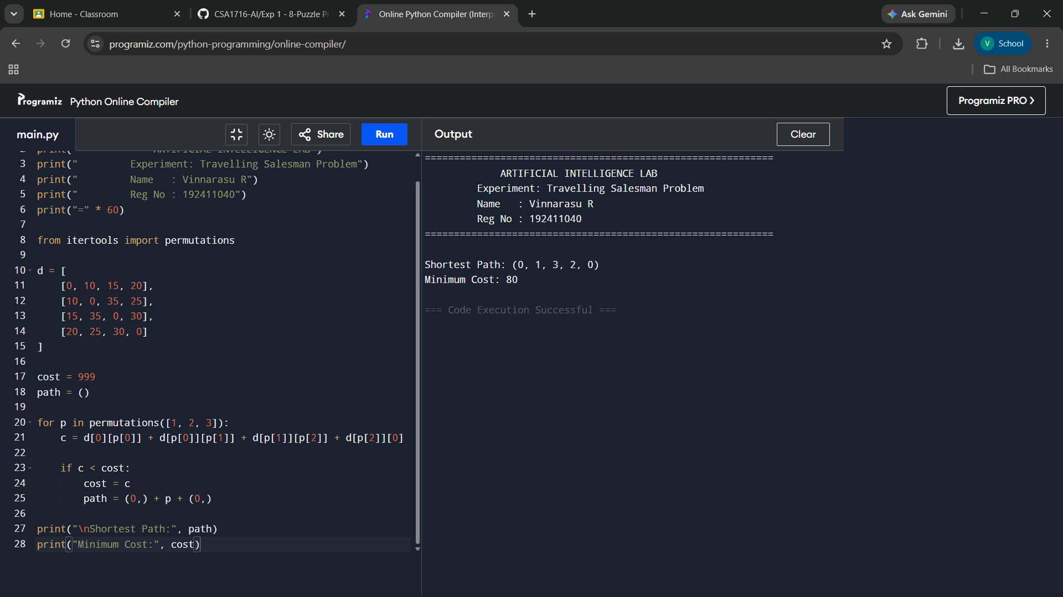
Result:
The Travelling Salesman Problem was successfully solved using Python. The program generated all possible routes, compared their travel costs, and identified the shortest route with the minimum total distance.

